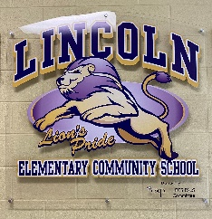
Principal: Fern Touchie Instagram: @lincolnlions2021
Administrative Assistant: Susanna Withers Twitter: @lincolnlion2021 Phone: 357-4075 Website: http://lincoln.nbed.nb.ca

Lions’ Pride. Lead and Learn with the Lincoln Lions

October 2021
September Start up – Thank you for a great September start up. Always remember that communication between home and school is what ensures a successful school year. Please do not hesitate to contact your child’s teacher if you have any questions or concerns during the school year!
Communication – In our efforts to ensure effective communication between home and school, we have our website, school messenger, Instagram & Twitter accounts. Please see above for the links and add us!
Fire Drill & Lockdown Practice – During the month of September students have practiced the procedures and expectations for both a school wide fire drill and school lockdown. They did a wonderful job performing both drills. These procedures will be practiced periodically throughout the year to ensure your child’s safety.
Terry Fox Fundraiser – We participated in our Terry Fox Walk on September 29th as a whole school. Lincoln Lion even came out to see everyone! After tallying the funds online and cash donations, LECS students raised $2717.75!!!! They more than doubled their initial $1200.00 goal! LECS students have shown great compassion and support for the Terry Fox campaign and cancer research. We have awesome students here at LECS! Students will vote this week on what is in store for Mrs. Touchie
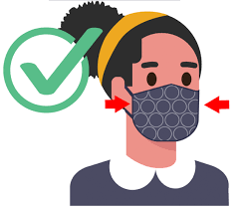
Mask Wearing – Just a reminder that under the Public Health guidelines, students are to wear their masks inside school. The masks are to be worn properly over the nose and the mouth. We are only able to approve community face mask and single use disposable masks at school. If your child is not following the guidelines, we will be required to send your child home for the day. If you could have a conversation with your child to reiterate the importance of wearing the mask to ensure their safety it would be appreciated.
Kindergarten Registration – Registration will take place at Lincoln Elementary Community School the week of October 12th – 15th. If you have a child who will turn five by December 31, 2022 and who will start school in September 2022, please contact the office at 357-4075 to arrange an appointment as we require your child’s birth certificate, immunization, and Medicare card.
School Supplies – If you have not dropped off your child’s school supplies, please send them in with your child so that they have what they need daily.
Hot Lunch – Our Hot Lunch Program started Monday October 4th. It will be available on Mondays, Tuesdays, & Wednesdays only. Online ordering is the only option and payment method available.
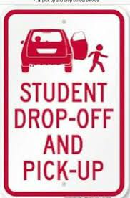
Student Drop off – Thank you for your patience and respecting the procedures we have implemented this time of year for our drop off. Just a reminder to please be mindful of your speed when entering the school driveway and to wait until there is space to pull up to the sidewalk. We would also ask that you not leave your car to walk your child to the school door. We are trying to instill independence in our students moving into the month of October and it also helps to move the traffic along in the morning. Thanks for your cooperation.
Home Learning – In the event of a closure due to COVID exposure, your child’s teacher has shared with you the expectation and how home learning will occur for their class. If you have any questions, please reach out to your child’s teacher.
PALS & PSSC – Thank you to those parents that reached out to volunteer on our school committees! Our PALS meeting will take place October 6th at 6:30 pm and our PSSC will be on October 20th at 6:30 pm. If you would like to take part in our PSSC meeting as it is open to all please message Mrs. Touchie at fern.touchie@nbed.nb.ca and she will add you to the virtual meeting.
Appropriate Clothing – It is so hard to predict the weather this time of the year. Our students are outside for three recess times & Phys Ed class on nice days. Please send a jacket for them to wear during the morning outside times.

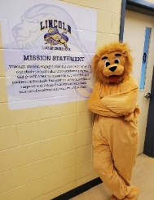
Lincoln Lion’s Monthy Roar!
We would like to give a shout out to the following students for showing amazing citizenship character through their fundraising initiatives during the month of September.
- Bennett Barr– Raised $1440.00 selling pumpkins, gourds, and other fall treats along with his brother, Everett for the LECS hot lunch and breakfast program. Bennett wanted to raise this money for students in need at LECS school.
- Declan Callaghan – Raised $500.00 for the annual Terry Fox Campaign through his initiative of selling Cancer Awareness Ribbons!
We are so proud of these students along with all the LECS students who worked so hard to double our Terry Fox fundraising goal!!!! We will share photos of our celebratory activities on our social media accounts soon

October’s CARE theme:
Perseverance & Grit
Perseverance is not a long race; it is many short races one after another
~ Walter Elliott
This month we are learning about what it means to not give up and try our best!

How Parents Can Teach Children Grit
- Let your child find a passion
- Place kids in an activity out of their comfort zone
- Let your child get frustrated
- Model a Growth Mindset
- Brainstorm Together
- Teach that Failing is OK
- Discuss Effort not Accomplishments
- Be a Gritty Parent

DAtes to Remember
Fire safety week – Oct 4th – 8th
School Picture Day – Oct 5th
PALS Virtual Meeting – Oct 6th @ 6:30pm
Thanksgiving day (No School) – Oct 11th
Kindergarten REgistration Week (students entering School in Fall 2022) – Oct 12 – 15th
Bus safety week – Oct 18th – 22nd
PSSC Virtual Meeting – Oct 20th @ 6:30 PM

